GADE7321 POE Part 1

Caden Hanger – ST10027083

Finite State Machine Diagram
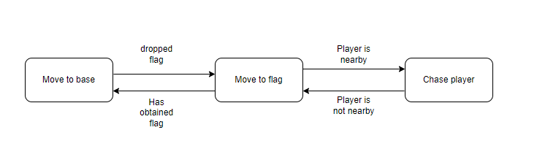

Link to GitHub Repository

https://github.com/Caden-Git/GADE7321-POE-Part-1

